February NEWS 4 YOU
Four Rivers
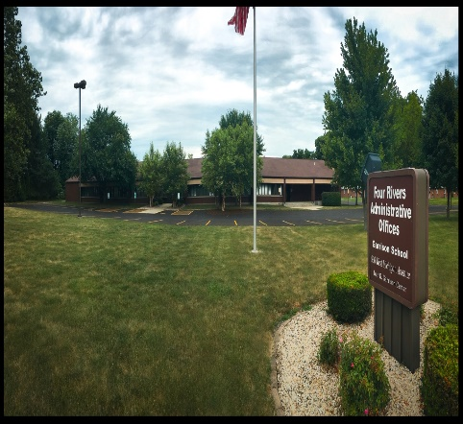

Upcoming Events
February 15th Mental Health First Aid (full-call Cindy Moore at 245-7174 ext. 309 to be put on the waiting list)
February 17th Alternatives to Suspension (can receive AA credit for)
March 23rd Universal Design for Learning: Supporting All Students
April 4th/5th Developing Culturally & Linguistically Responsive Practice within a Multi-tiered System of Supports for English Learner’s
April 19th Initial CPI
April 26th Parent training on Autism topics
April 27th Training on Autism topics by Corey Moore (title TBD)
June 6th and June 7th Initial CPI

936 W. Michigan Jacksonville, IL 62650
www.frsed.org 217 245-7174
Dear Reader,
Happy February! We are so excited to share this newsletter with you. It will appear monthly on our website as well. Feel free to email Melissa Morrissey (mmorrissey@frsed.org) with ideas for future issues.
Sincerely,
Four Rivers Supervisors

REMINDER
When completing forms that the parents have to sign, such as Medicaid, excusals, etc. please make sure the entire form is filled out. We need more than just the parent signature.
When doing transition plans, please include the exact date assessments were given on Screen 44 in the date conducted boxes.

“A teacher is a compass that activates the magnets of curiosity, knowledge, and wisdom in the pupils.” -Ever Garrison

GARRISON NEWS

January is flying by at the Garrison School. Unfortunately, we have had some cases of Influenza B and the stomach flu. Remember if your child is sent home from school with a fever or vomiting, we ask that they be kept home for 24 hours after the fever is gone or the vomiting has stopped. We want to keep everyone as safe as we can and this helps us manage the spread of the illness.
We have two PBIS activities this month. Our students are doing a paper chain around the perimeter of the Garrison halls and the psychologist hallway. Each link has a student’s name on it. That student has performed an act of kindness for a peer or staff member. So far, the students have earned a movie, popcorn, and a candy bar. We are working on the soda. Great job on being kind in January Garrison students. The individual activity was pancakes. Twenty six students earned pancakes with strawberries, blueberries, or chocolate chips. I heard it was delicious.
Once again, a big shout out to all who helped the Garrison School. MD, and EC programs provide Christmas gifts to our students. The students were very appreciative and want to thank you for your kindness. We are blessed to work in such a caring environment.

Brushing Up on Fape (cont.)
Failure to provide persons with disabilities with an appropriate education frequently occurs as a result of misclassification and inappropriate placement. It is illegal to base individual placement decisions on presumptions and stereotypes regarding persons with disabilities or on classes of such persons. For example, it would be a violation of the law for a recipient to adopt a policy that every student who is hearing impaired, regardless of the severity of the child’s disability, must be placed in a state school for the deaf.
A school district must conduct or arrange for an individual evaluation at no cost to the parents before any action is taken with respect to the initial placement of a child who has a disability, or before any significant change in that placement.
Recipients of ED funds must establish standards and procedures for initial and continuing evaluations and placement decisions regarding persons who, because of a disability, need or are believed to need special education or related services.
These procedures must ensure that tests and other evaluation materials:
- have been validated for the specific purpose for which they are used, and are administered by trained personnel in conformance with the instructions provided by their producer;
- are tailored to assess specific areas of education need and are not designed merely to provide a single general intelligence quotient; and
- are selected and administered so as best to ensure that, when a test is administered to a student with impaired sensory, manual, or speaking skills, the test results accurately reflect the student’s aptitude or achievement level or whatever other factor the test purports to measure, rather than reflecting the student’s impaired sensory, manual, or speaking skills (except where those skills are the factors that the test purports to measure).
Recipients must draw upon a variety of sources in the evaluation and placement process so that the possibility of error is minimized. All significant factors related to the learning process must be considered.
These sources and factors include, for example, aptitude and achievement tests, teacher recommendations, physical condition, social and cultural background, and adaptive behavior. “Adaptive behavior is the effectiveness with which the individual meets the standards of personal independence and social responsibility expected of his or her age and cultural group.” (See Appendix A to 34 CFR Part 104, Evaluation and Placement.)
Information from all sources must be documented and considered by a group of knowledgeable persons, and procedures must ensure that the student is placed with nondisabled students to the greatest extent appropriate.

From https://www2.ed.gov/about/offices/list/ocr/docs/edlite-FAPE504.html

PAPERWORK/FORM REMINDERS
- IEP, invitation, data form, and ten-day waiver.
  - The dates should match what is printed on the invitation (Form D)
  - The date on the data form should match what is listed on the IEP, which should match what is listed on the invitation.
- 10-day Waiver Form
  - Please count the days, correctly. If an invitation is sent out on January 27th, that is day one of 10 calendar days required for parent notification.
  - This is the only form that is used to waive the 10 days for a meeting or to initiate an evaluation.
- Letter of Recommendation Form (Form E)
  - Parents only sign this form if there has been a change of placement. Parents do not sign this for any other reason.
- Printing
  - Please print the correct paperwork to match the type of meeting that was held. If there was no eligibility determination meeting held – then do not run off this part of the paperwork.
  - If it is only an annual review, or just an IEP meeting – that is all that is printed off – the IEP, only.
  - Make sure and print off the correct EDC paperwork, according to what the student’s eligibility is – if the student is only eligible under Autism, do not print off EDC paperwork for Specific Learning Disability.
- Paperwork needs to be in a specific order. Please refer to the paperwork checklist to ensure you put your paperwork in the proper order.
- Data forms
  - Please put the dates for the different types of meetings on your forms.
  - Begin dates – this is for any new service that is starting, switching class lists, when they started in the district (if they moved in)
  - End date – this is for when any service ends or when they move. If the student moves, this date must match what has been entered into SIS. Please verify this with your SIS person in your district.

THANK YOU!

