December NEWS 4 YOU
Four Rivers
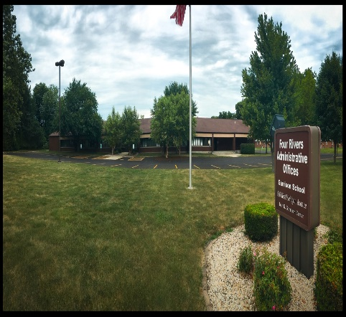

Upcoming Events
Keep checking back to the Four Rivers website for next year’s inservice offerings.
HALT
This handy acronym reminds
us to take a moment (HALT)
and ask ourselves if a student
is feeling Hungry, Angry,
Lonely, or Tired. It seems
simple enough, but when
these basic needs are not
met, individuals are more
likely to inappropriately
express these needs through
behavior.

936 W. Michigan Jacksonville, IL 62650
www.frsed.org 217 245-7174
Dear Reader,
We have almost completed another semester! Hold on! Break is near!
Sincerely,
Four Rivers Supervisors
Science and PE Assessment
Esped has been updated on Screen 35 to reflect the new
Scholastic Aptitude Test (SAT), Illinois Science Assessment, and
Physical Fitness Assessment. Please make sure you have marked
the correct boxes and added accommodations as needed. If you have already met on a student this year, you will have to amend
the IEP. Contact your supervisor with any questions.

Be SOMEBODY who makes EVERYBODY feel like
a SOMEBODY. –Kid President

More Important News
When sending in data forms, please make sure the begin date on new students and the end date on students who are leaving match what your office has entered into their state data systems.

CPI
Recently some Four Rivers staff received new, enhanced CPI training. In light of the new training, any training for CPI this year will now be initial training. Please contact your supervisor if you have questions and watch the Four Rivers website (www.frsed.org) for upcoming initial CPI training opportunities.

Resources
Free transition lesson plans can be found on Teachers Pay Teachers.
Go to: https://www.teacherspayteachers.com/Store/National-Technical-Assistance-Center-On-Transition

Don’t forget to try out the new features for goal writing on IEPQ.
Go to: https://iepq.education.illinois.edu/

Are you giving students access to grade level materials? Send your name and address to mmorrissey@frsed.org to get free access to Learning Ally. Features include audio access at school and home to textbooks, novels, and more! Learning Ally also offers free webinars to teachers and parents.

Garrison Happenings

The Garrison Gators are preparing for the holidays. There is an Angel Tree in the lobby of the Four Rivers Special Education District lobby. The students from the Garrison program along with the Early Childhood and Multiply Disabled classrooms have filled out a stocking with Christmas wishes. We ask that no one spend more than $25. Please attach either the stocking or the child’s name on the gift. They should be wrapped and under the tree by December 16th. Santa has promised to make a visit on December 21st at 10 a.m. We are so glad he could fit us in his busy schedule. He will be passing out gifts in the lobby to all the students. Please join us if you can.

We did have our annual Thanksgiving Dinner on November 17. Staff raised money through yard sales and Jeans day to help pay for the dinner. Thank you to everyone who contributed in any way. Not only did our staff donate desserts and sides such as corn and green beans, but several local businesses assisted as well. Thank you to County Market, Norma’s North Star restaurant, and Grandma Rudi’s for their contributions. It does take a village sometimes. The students were very appreciative of the delicious meal which has been a Garrison tradition for many years. When it originated, the Garrison staff cooked the entire meal including the turkeys. Through the years, the dinner has changed. It was catered for several years. It is now a combination of catered and staff preparation. We feel blessed to share this day with our students.

The Garrison staff and students would like to wish you all a happy Thanksgiving and safe travels this holiday season. Thank you for all you do for the children in our cooperative.

BRUSHING UP ON FAPE

Who Is Entitled to FAPE?
All qualified persons with disabilities within the jurisdiction of a school district are entitled to a free appropriate public education.

How Is an Appropriate Education Defined?
An appropriate education may comprise education in regular classes, education in regular classes with the use of related aids and services, or special education and related services in separate classrooms for all or portions of the school day. Special education may include specially designed instruction in classrooms, at home, or in private or public institutions, and may be accompanied by related services such as speech therapy, occupational and physical therapy, psychological counseling, and medical diagnostic services necessary to the child’s education.
An appropriate education will include:
- education services designed to meet the individual education needs of students with disabilities as adequately as the needs of nondisabled students are met;
- the education of each student with a disability with nondisabled students, to the maximum extent appropriate to the needs of the student with a disability;
- evaluation and placement procedures established to guard against misclassification or inappropriate placement of students, and a periodic reevaluation of students who have been provided special education or related services; and
- establishment of due process procedures that enable parents and guardians to:
  - receive required notices;
  - review their child’s records; and
  - challenge identification, evaluation and placement decisions.
Due process procedures must also provide for an impartial hearing with the opportunity for participation by parents and representation by counsel, and a review procedure.
…MORE NEXT MONTH
(from http://www2.ed.gov/about/offices/list/ocr/docs/edlite-FAPE504.html)

