Emotional Poverty in All Demographics
How to Reduce Anger, Anxiety, and Violence in the Classroom
Wednesday March 11, 2020
8:30 am – 11:30 am
Four Rivers Staff 12:30 pm – 3:30 pm
Presented by Bethanie Tucker, based on the book by Ruby Payne
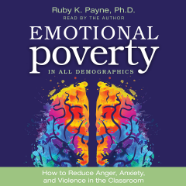

Address anger, anxiety, and violence in the classroom with strategies and best practices that work in classrooms. Under-resourced students, wealthy students, and students in all demographics can benefit from calming and healing techniques as Ruby Payne, author of A Framework for Understanding Poverty, shares in this book. It:
- Provides understandings of origins of anger, anxiety, and avoidance
- Gives a language to talk about brain regulation, integration, and emotional competence
- Provides tools for educators to address and reduce anger, anxiety, and avoidance
- Helps educators manage the “classroom dance” that occurs between the educator and the students
- Provides the tools to motivate good behavior
- Identifies the differences in male and female emotional processing

Register on-line at www.frsed.org under the Professional Development Tab.
Four Rivers Special Education District
936 W. Michigan Ave. Jacksonville, Il

