January NEWS 4 YOU
Four Rivers
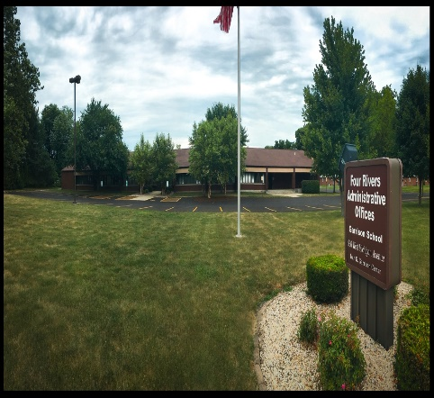

Upcoming Events
Keep checking back to the Four Rivers website for inservice offerings.
Training Opportunities
On February 27th, Starnet will be offering a free workshop called Building Your Inclusion Toolbox presented by Erin Barton, Vanderbilt University & Kathy Whaley, ECTA at the ISU Alumni Center in Normal, IL. To register go to www.starnet.org.
For other early childhood information go to www.eclre.org

936 W. Michigan Jacksonville, IL 62650
www.frsed.org 217 245-7174
Dear Reader,
Happy New Year!
Sincerely,
Four Rivers Supervisors
Science and PE Assessment
Esped has been updated on Screen 35 to reflect the new
Scholastic Aptitude Test (SAT), Illinois Science Assessment, and
Physical Fitness Assessment. Please make sure you have marked
the correct boxes and added accommodations as needed. If you have already met on a student this year, you will have to amend
the IEP. Contact your supervisor with any questions.

"An investment in knowledge pays the best interest."
—Benjamin Franklin

Resources
Just a reminder that assessments written into the secondary transition plans must have occurred, prior to writing the plan and need to include the dates they were given.

Assessments can be both formal and informal. A few examples of assessments include: Career Cruising, PSAE, Interest Inventories, Independent Living Skills Questionnaire, Social Skills Inventories, SAT, ASVAB, Student Interview Inventory, Family Interviews, Employability Skills Inventory. Resource for this information is from the 12th Annual Illinois Statewide Transition Conference (October 2016); Susan Walter’s presentation, “Where Compliance Meets Evidence Based Practices.”

Transition resources: The career videos contained here are designed to provide a brief, visual introduction to careers and the world of work and supplement more detailed sources of career information. All of the videos were recorded in actual places of work with real employees. Each career video averages 90 seconds in length and typically covers the rewards and compromises of the specific career, as well as skill requirements and duties.
http://careerconnections.nj.gov/careerconnections/plan/career/videoenglish/career_videos.shtml

Another great transition resource is http://transitionta.org/. NTACT’s purpose is to assist State Education Agencies, Local Education Agencies, State VR agencies, and VR service providers in implementing evidence-based and promising practices ensuring students with disabilities, including those with significant disabilities, graduate prepared for success in postsecondary education and employment.

Don’t forget to try out the new features for goal writing on IEPQ.
Go to: https://iepq.education.illinois.edu/

Are you giving students access to grade level materials? Send your name and email address to mmorrissey@frsed.org to get free access to Learning Ally. Features include audio access at school and home to textbooks, novels, and more! Learning Ally also offers free webinars to teachers and parents.

BRUSHING UP ON FAPE

Education Services Must Meet Individual Needs
To be appropriate, education programs for students with disabilities must be designed to meet their individual needs to the same extent that the needs of nondisabled students are met. An appropriate education may include regular or special education and related aids and services to accommodate the unique needs of individuals with disabilities.
One way to ensure that programs meet individual needs is through the development of an individualized education program (IEP) for each student with a disability. The quality of education services provided to students with disabilities must equal the quality of services provided to nondisabled students. Facilities must be comparable, and appropriate materials and equipment must be available.
Students with disabilities may not be excluded from participating in nonacademic services and extracurricular activities on the basis of disability. Persons with disabilities must be provided an opportunity to participate in nonacademic services that is equal to that provided to persons without disabilities. These services may include physical education and recreational athletics, transportation, health services, recreational activities, special interest groups or clubs sponsored by the school, and referrals to agencies that provide assistance to persons with disabilities and employment of students.

Students With Disabilities Must Be Educated With Nondisabled Students
Students with disabilities and students without disabilities must be placed in the same setting, to the maximum extent appropriate to the education needs of the students with disabilities. A recipient of ED funds must place a person with a disability in the regular education environment, unless it is demonstrated by the recipient that the student’s needs cannot be met satisfactorily with the use of supplementary aids and services. Students with disabilities must participate with nondisabled students in both academic and nonacademic services, including meals, recess, and physical education, to the maximum extent appropriate to their individual needs.
As necessary, specific related aids and services must be provided for students with disabilities to ensure an appropriate education setting. Supplementary aids may include interpreters for students who are deaf, readers for students who are blind, and door-to-door transportation for students with mobility impairments.

…MORE NEXT MONTH
(from http://www2.ed.gov/about/offices/list/ocr/docs/edlite-FAPE504.html)

Please remember to make your drafts active after you disperse IEPs.

And please remember to give your domain packet to the school psychologist prior to scheduling the domain meeting.
Just a Note
Other Early Childhood News

The Early Childhood Block Grant will be coming soon.
You can access this information at www.isbe.net

Also, an Illinois Early Childhood Summit will be held on February 28th at ISU Alumni Center, Normal IL.
The purposes of the Summit are to:
- Create a shared awareness of the state of early childhood
inclusion policy in Illinois

- Develop priorities for improving policy to support inclusion of young children across all agencies and stakeholders in Illinois

- Facilitate a true working meeting among leaders in early
childhood systems in Illinois

Garrison News
Garrison is winding down the first semester of this year. We had an awesome visit today with that jolly old man from the North Pole. Yes, Santa stopped by Four Rivers.
He passed out gifts to the Garrison students as well as the MD and EC programs. The students were appreciative. A special thank you to all of Santa’s Helpers who provided gifts to our students.
The Garrison Staff and students would like to wish a Merry Christmas and Happy Holiday season to all of our school family in the cooperative. See you next year!!!

