November NEWS 4 YOU
Four Rivers
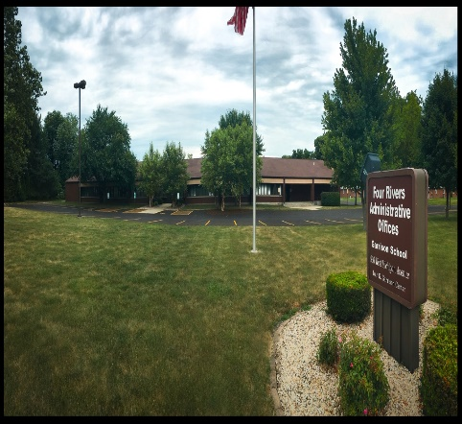

Upcoming Events

November 3
Enhanced Initial CPI 8-4
Currently full. Contact Cindy Moore (cmoore@frsed.org) to be put on the waitlist.

November 15
IEP-Q 9:30-3:30
Currently full. Contact Cindy Moore to be put on the waitlist.
November 18
EC Roundtable 9-11:30
November 21
Integrating Speech into the Early Childhood Classroom 1-3
November 30
Autism Spectrum Disorders 8:30-11:30
NOTE: Because of changes in the data system it would be VERY helpful if you could include the SIS ID on ALL data forms.

936 W. Michigan Jacksonville, IL 62650
www.frsed.org 217 245-7174
Dear Reader,
Welcome to November and fall! We are so excited to share this newsletter with you. It will appear monthly on our website as well. Feel free to email Melissa Morrissey (mmorrissey@frsed.org) with ideas for future issues.
Sincerely,
Four Rivers Supervisors

CPI
Recently some Four Rivers staff received new, enhanced CPI training. In light of the new training, any training for CPI this year will now be initial training. Please contact your supervisor if you have questions and watch the Four Rivers website (www.frsed.org) for upcoming initial CPI training opportunities.

Important Announcement
Domain meetings and Garrison meetings will not be scheduled until the necessary packets are received. If you have questions, please contact your program supervisor.

Garrison News
The Garrison School continues to provide opportunities for our students to expand their horizons with the help of some important staff members. A group of juniors and seniors used West Central Mass Transit to attend a transition event at ISD. The students asked meaningful questions about their future as well as learned more about deaf culture. Unfortunately, we had to cancel the Four Rivers Transition Fair due to lack of participation. We hope to provide the event in the future and will be doing a survey at some point to see what districts would be interested in. Mrs. Radliff, Mrs. Beddingfield, Mrs. Maly, and Mrs. Hoots, thank you for making the ISD trip happen. Thank you Mrs. Pennell for your continued support also.
Another event our students earned was a walk to Wendy’s for a treat. Twenty nine students were able to attend. Mrs. Certa, SSW, got to walk with both groups. Thank you Mrs. Certa and the Garrison staff who chaperoned the activity.
Speaking of our social workers, Mrs. Certa and Mrs. Brawdy have been going to student homes after school to become better acquainted with our families. The students are excited to show the ladies their homes. It also builds the relationship between school and family. Here is a special shout out to the ladies for going the extra mile for our students! We are truly blessed to have such dedicated individuals providing service to our kids.
Last but not least, Melissa Linderman, Occupational therapist, provided a workshop to our staff on sensory interventions the staff can do with the students. Along with a Q and A session, she demonstrated different things that can be done quickly but produce positive results. The staff was appreciative and have implemented several of her suggestions. Thank you Melissa for your time!! More information on our OT services can be found on our website: http://frsed.org/occupational-therapy/

More Important News

Registration for inservices has changed. You will no longer receive an automatic email. Instead, two weeks prior to the inservice you will receive a confirmation letter.

REQUIRED TRAINING FOR DLM
- Required training is now open for all users for the 2016-2017 school year.
- All training needs to be completed by January 27th, 2017.
- New users need to be added by January in order to complete the required training. It takes 48 hours for an account to be established in Moodle for the required training.
- If you are new to the district and have completed the training in another district, then please update your user account with your new email address and district information.

Data Lockdown
- Data lockdown begins February 6th, 2017.
- All rosters, required training, and users must be added prior to this date.
- All grade level corrections must also be completed prior to this date. If you are correcting a grade level, please make sure the grade is also changed in SIS.

Individual Score Reports
- The Individual Student Reports (ISRs) are available for the 2015-2016 in the Educator Portal as individual reports or bundled reports.
- District Superintendent, District Test Coordinator, Building Test Coordinator, and Building Principal have access to these reports.
- Scoring and Reporting Resources for Year End States can be found at the following website: http://dynamiclearningmaps.org/srr/ye
Rosters
- DLM staff has discovered an issue with the roster tool. When selecting your district and school, the list of educators to choose from will total around 6,000. DLM staff are currently working on this issue.

Resources for Instructionally Embedded - English
http://dynamiclearningmaps.org/content/educator-resource-page/ELA
Resources for Instructionally Embedded - Math
http://dynamiclearningmaps.org/content/educator-resource-page/Math
Resources for Instructionally Embedded - Familiar Texts Used in Multi-EE Testlets
http://dynamiclearningmaps.org/content/familiar_texts_multi_ee_ye

